Step 1: Place the below files in a “build-custom-html-user-review-Agent” folder
- Need to Export the “User Story Review Agent -May Gen AI” from Langflow.
- Need to Export the collection from “User_Review_Agent.postman_collection” from Postman.
- Write the prompt in the file and store in prompt.md file

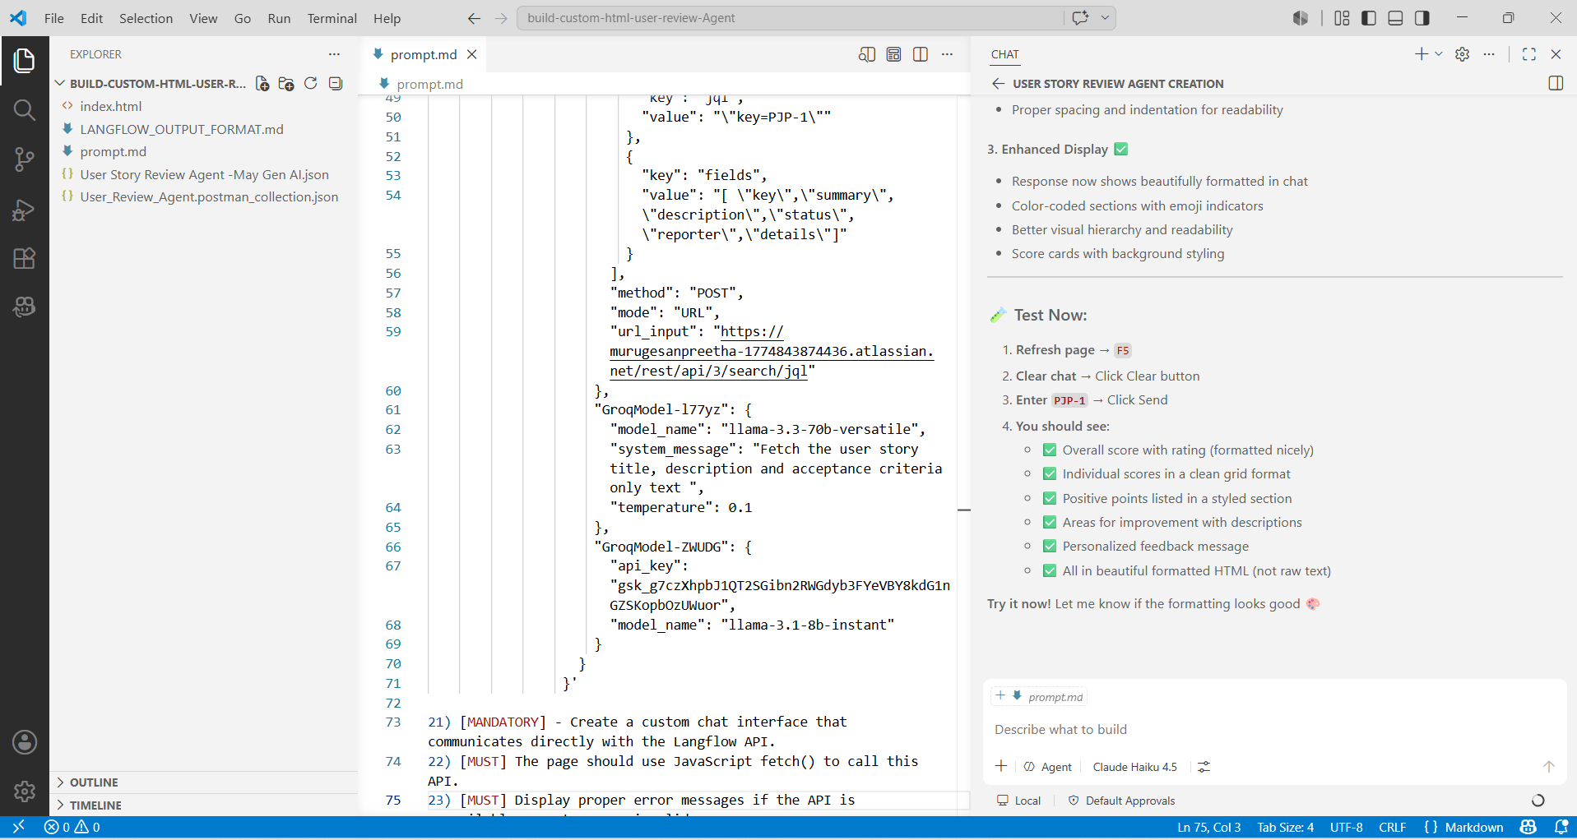

Step 2: Prompt
CONTEXT:

As a frontend developer, I want you to build a web page for the QA and BA to analyse the user story and rate it with a score.

I have already created a Langflow workflow to connect with JIRA to fetch the user story, and then added the LLM to rate it.

I can share the API details. You can integrate it in a single html page.

INSTRUCTION

1) [MANDATORY] - Add Heading of the Tool as "AI POWERED USER STORY REVIEWER"
2) [CRITICAL] - Add a chat for the user to enter the JIRA user story ID, so that it can be taken as an input and rating can be done
3) [MANDATORY] Chat has to be opened by default and the chat window should be from top of the screen to bottom with the default width
4) [MANDTORY] Give the user friendly instructions on how to use the User Story Reviewed in the left side of the page
5) [MANDATORY] Give an option to copy paste the sample user stories for the user. Make sure samples are given in detail
6) [MANDATORY] Implement clear option to clear the chat
7) [CRITICAL] Implement score bucketing, with comments. If the score is above 90% mark it as excellent. Add the positive points and ask user to continue that.
8) [CRITICAL] If the score is between 80% - 90% mark it as Good. Add the positive points and ask user to continue that. And mention what is missing in the requirements
9) If the score is between 70% - 80% mark it as Okay. Add the positive points and ask user to continue that. And mention what is missing in the requirements
10) If the score is less than 70% mark it as Not meeting the standard. Mention what is missing in the requirements

11) [MANDATORY] Add a button to download the results as a report.
12) [MANDATORY] Add Proper scrolling options with scroll bars
13) [MANDATORY] Add Thinking when you are generating the output
14) [MANDATORY] I want you to use purple and light purple
15) [MANDATORY] - Have the request and response in the light shades of purple which co ordinates with the theme colour.
16) [MANDATORY] - Give the chat name as QA Genie
17) [MANDATORY] The page should connect directly to my Langflow API and allow users to submit a Jira User Story for review.
18) [STRICT] - DO NOT use the Langflow Embedded Chat component.
19) [MANDATORY] - Create all these requirements as fully functional single
-page HTML UI for an AI-powered Use case Reviewer
20) [MANDATORY] When the AI is reviewing a user story, show QA Genie is thinking

Below are my API details

curl --request POST \
--url 'http://localhost:7860/api/v1/run/d82050a7-900e-4d12-80e1-af431ce6790b?stream=false' \
--header 'Content-Type: application/json' \
--header "x-api-key:sk-xFyOkLJ2iKfrbf_CLWpc9KRiJrdK53IHIFbTgyC10QA" \
--data '{
"output_type": "text",
"input_type": "text",
"input_value": "hello world!",
"tweaks": {
"APIRequest-NLo0y": {
"body": [
{
"key": "jql",
"value": "\"key=PJP-1\""
},
{
"key": "fields",
"value": "[ \"key\",\"summary\",\"description\",\"status\",\"reporter\",\"details\"]"
}
],
"method": "POST",
"mode": "URL",
"url_input": "https://murugesanpreetha-1774843874436.atlassian.net/rest/api/3/search/jql"
},
"GroqModel-l77yz": {
"model_name": "llama-3.3-70b-versatile",
"system_message": "Fetch the user story title, description and acceptance criteria only text ",
"temperature": 0.1
},
"GroqModel-ZWUDG": {
"api_key": "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",
"model_name": "llama-3.1-8b-instant"
}
}
}'

21) [MANDATORY] - Create a custom chat interface that communicates directly with the Langflow API.
22) [MUST] The page should use JavaScript fetch() to call this API.
23) [MUST] Display proper error messages if the API is unavailable or returns an invalid response.

Example:

As a customer,
I want to transfer funds between my accounts,
So that I can manage my finances without visiting a branch.
Acceptance Criteria:
• User can select source account
• User can select destination account
• User can enter transfer amount
• Amount must be greater than zero
• Confirmation message should be displayed
• Transaction should be saved successfully

OUTPUT
I would like the page to have a professional and easy-to-use design.
The chat interface should appear on the top-right side of the page.
Users should be able to:
• Open the review agent
• Close the review agent
• Submit a user story
• View review results
• Copy review results
• Clear chat history
Provide buttons to:
• Copy Sample User Story
• Paste Sample User Story into Chat

Every AI response should have a Copy button.
Include a Clear Chat button.
Use modern styling with cards, shadows, rounded corners, and responsive design.

User Story Review Agent -May Gen AI.json file is exported from Langflow and User_Review_Agent.postman_collection.json is exported from Postman. Use these for reference to understand how it has been implemented.
Step 3: AI Powered user story reviewer is created using the vibe coding
